WEB APPLICATION ARCHITECTURES

Ajax

Objectives

In this exercise you will investigate Ajax

Reference material
This exercise is based on material from the “Ajax” chapter.

Overview
- In this exercise you will experiment with Ajax using JQuery

Estimated duration
The estimated duration for this lab is ~45 minutes.

Completed solution
There is a completed solution for this lab.

Step by step instructions

Part-1

Investigate Ajax and Web services
In this part you’re not expected to write any code.
First of all, you will run a web server on your own computer. To do this:
- Locate the WebService folder within the starters folder for this chapter
- Double click on the RunMe.bat file to start the server.
This will open up a Command window.
- When finished (but not yet!), press Ctrl-C to end the web server
Next, use a code like the ones on the slides to get customers data from http://localhost:5000/customers and then display the ContactName attribute of each customer
Please use Ajax’s getJSON() method which automatically de-serializes the JSON data and sends an array of objects into the callback function.

Part-2
- Go to https://api.tfl.gov.uk/Line/Mode/tube/Status and have a look at the results. Can you recognise that this URL returns some JSON data?
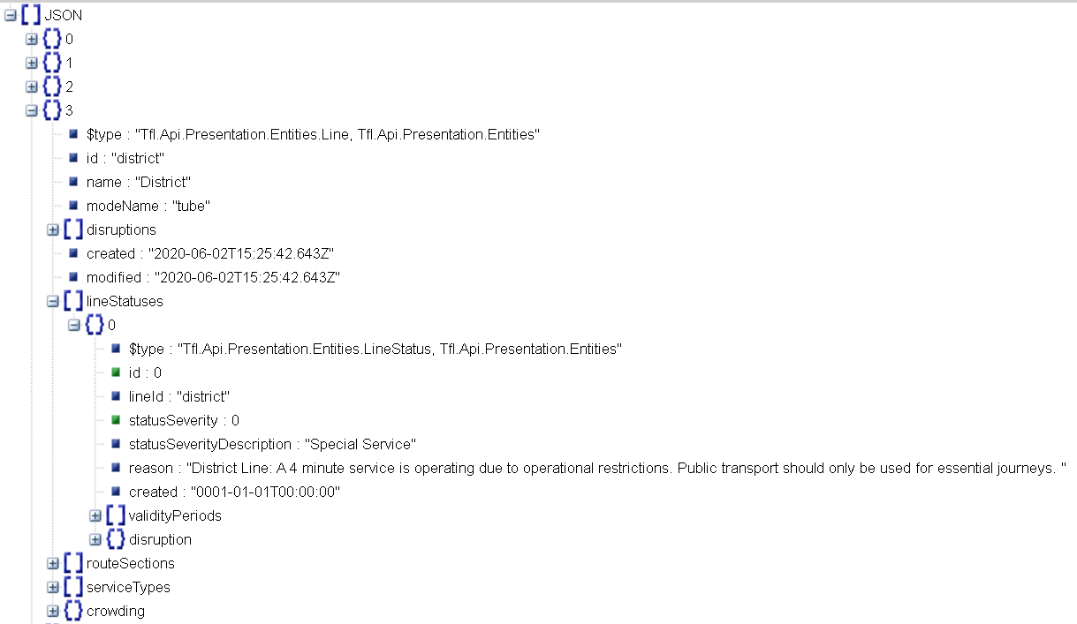
- Use Google to find a JSON formatter. Copy and paste the contents of the previous web request into a JSON formatter, and then examine the results. What do you think this JSON data is telling you?
- Create a web page which uses JQuery and AJAX to show the most relevant parts of the JSON data to the user:
  - You have seen examples of a button which fires an AJAX request. But in this case, it would be better if the AJAX request was fired as soon as the web page loads – the user shouldn’t have to take an extra step to initiate the action.
Therefore, inside the $(document).ready() function, you will need to add a call to $.getJSON()
  - Notice that the JSON contains an array. Therefore, you will need some kind of loop to go through each item in the array. An alternative would be to use $.each() to go through each item in the array.
  - For each item in the array, we are interested in its “name”.
  - Additionally, each item in the array contains a sub-array called “lineStatuses”.
We only need the first item from this sub-array – if there is more than one item in the array, you can just ignore everything except the first one.
From this first item, retrieve and display the “statusSeverityDescription”.
  - Ensure the data is displayed to the user in an appropriate format, so that the user can read it clearly!

